# AgroBot - Outputs (Task 2)

## 1. User Registration

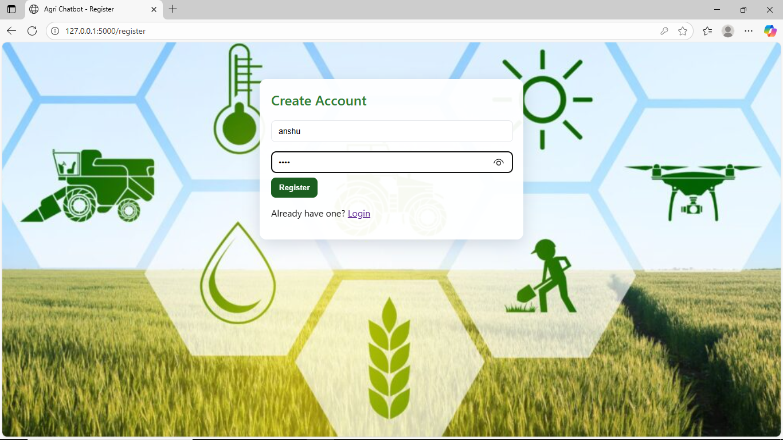

This page allows users to create a new account to access the Agri Chatbot.

## 2. User Login

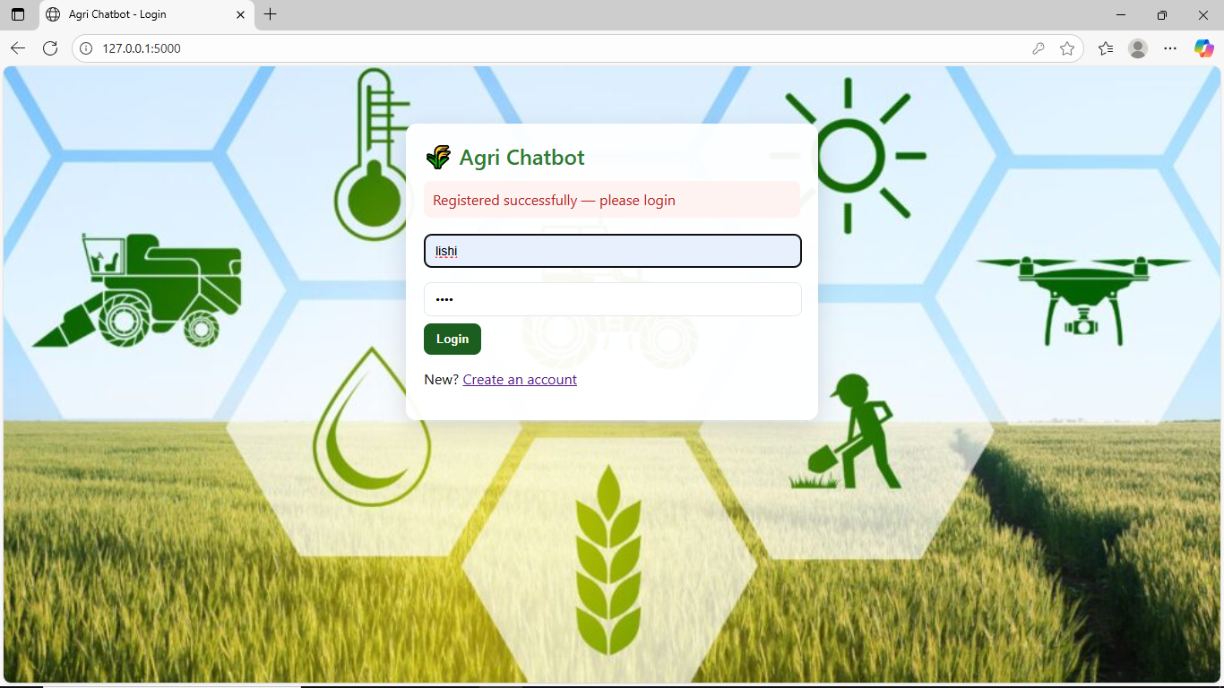

This page allows registered users to securely log in to the chatbot.

## 3. Chat Interaction (English)

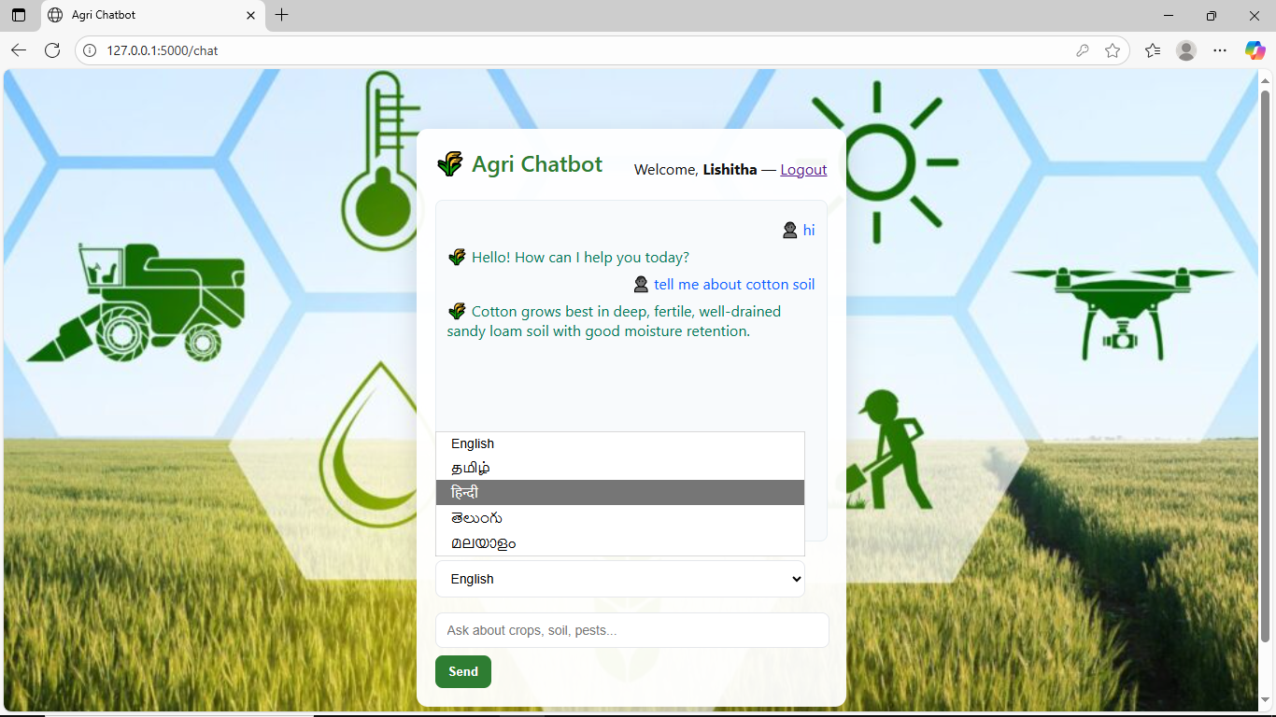

This interface shows the chatbot responding to user queries in English.

## 4. Chat Interaction (Other Languages)

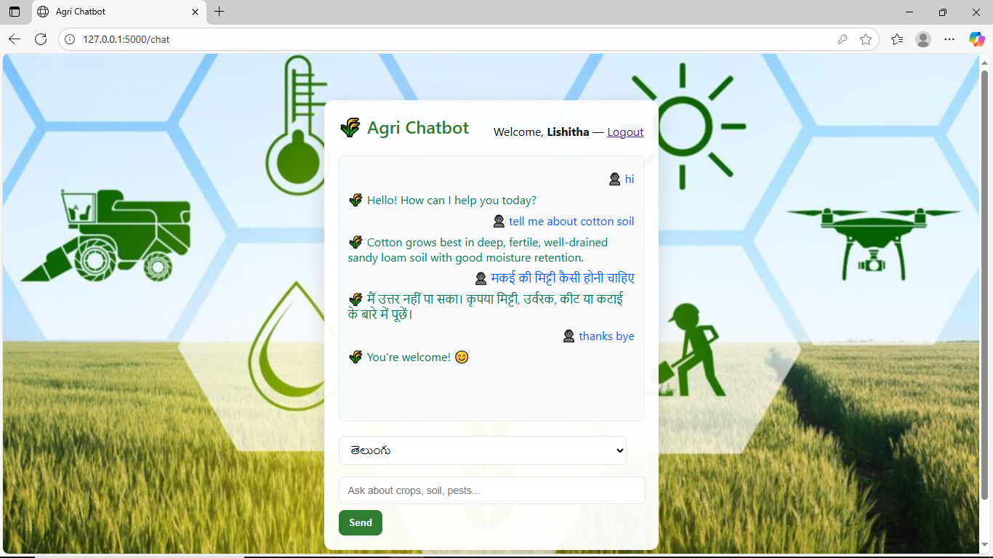

This page demonstrates multilingual chat interaction between user and bot.

## 5. Logout Page

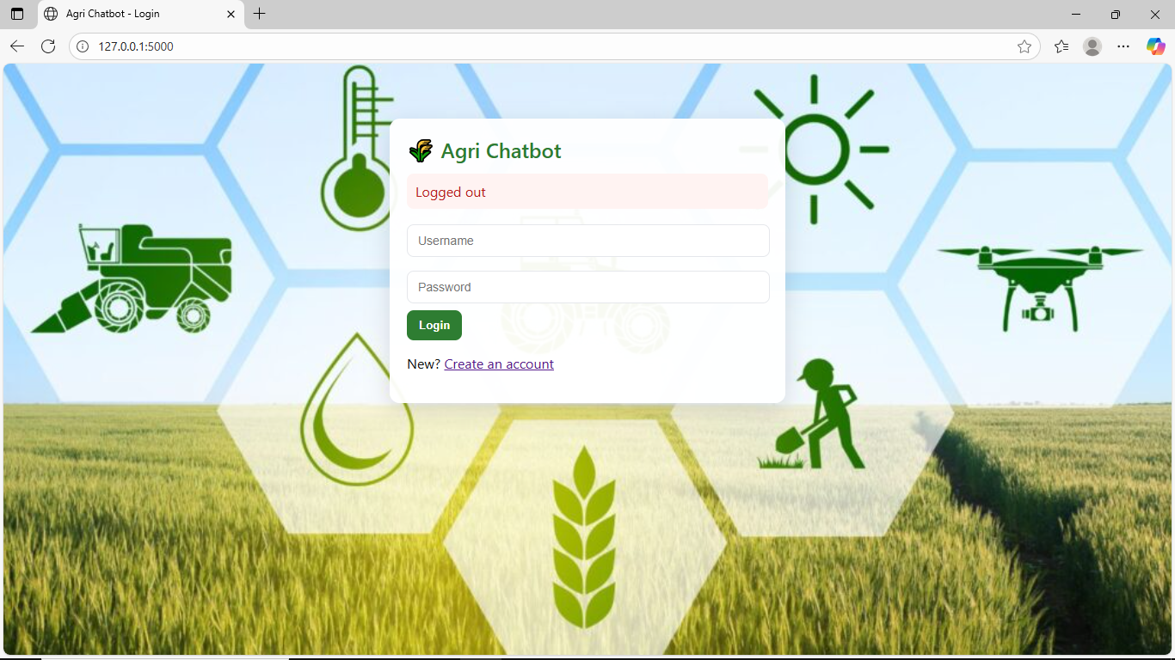

This page confirms that the user has successfully logged out.